**Assignment No.3**

**Q1. Write a program to merge two arrays of integers by reading one number at a time from each array until one of the array is exhausted, and then concatenating the remaining numbers. Input: [23,60,94,3,102] and [42,16,74] Output: [23,42,60,16,94,74,3,102]**

import java.util.Scanner;

class Hello

{

static void Merge(int arr1[],int arr2[],int arr3[],int n1,int n2){

int i=0,j=0,k=0;

while(i<n1 && j<n2){ //traverse the arr

arr3[k++]=arr1[i++];

arr3[k++]=arr2[j++];

}

while(i<n1){

arr3[k++]=arr1[i++];

}

while(j<n2){

arr3[k++]=arr2[j++];

}

}

public static void main(String args[])

{

Scanner sc=new Scanner(System.in);

System.out.println("Enter Array1");

int n1=sc.nextInt();

int[]arr1=new int[n1];

for(int i=0;i<n1;i++){

arr1[i]=sc.nextInt();

}

System.out.println("Enter Array2");

int n2=sc.nextInt();

int []arr2=new int[n2];

for(int i=0;i<n2;i++){

arr2[i]=sc.nextInt();

}

int arr3[]=new int[n1+n2];

Merge(arr1,arr2,arr3,n1,n2);

System.out.println("Array after merging");

for(int i=0;i<n1+n2;i++)

{

System.out.println(arr3[i]+" ");

}

}

}

//Output

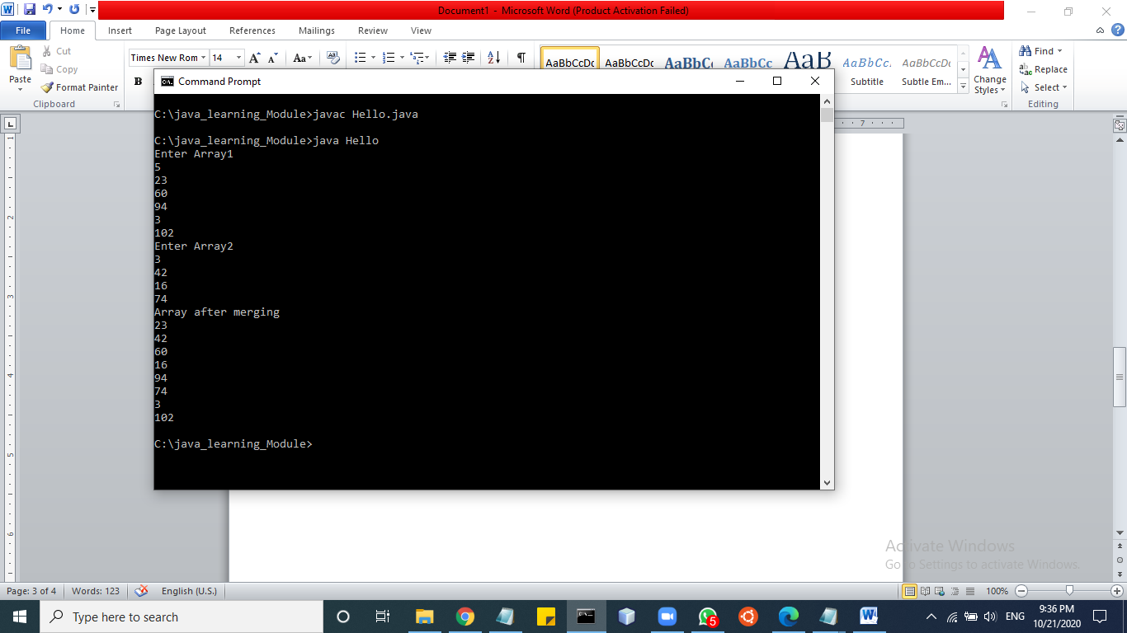

**Q2.Write a program which takes an array of integers and prints the running average of 3 consecutive integers. In case the array has fewer than 3 integers, there should be no output. Input: [5,14,35,89,140] Output: [18, 46, 88] (Explanation: 18=(5+14+35/3, 46=(14+35+89)/3, ...)**

import java.util.Scanner;

class Three

{

void getSum(int a1[],int n1)

{

for(int i=0;i<n1;i++)

{

int sum;

sum=(a1[i]+a1[i+1]+a1[i+2])/3;

System.out.println(sum);

}

}

}

class Hello

{

public static void main(String args[])

{

Scanner sc=new Scanner(System.in);

Three t1=new Three();

System.out.println("Enter size");

int n1=sc.nextInt();

int a1[]=new int[n1];

for(int i=0;i<n1;i++)

{

a1[i]=sc.nextInt()

}

t1.getSum(a1,n1);

}

}

**//Output**

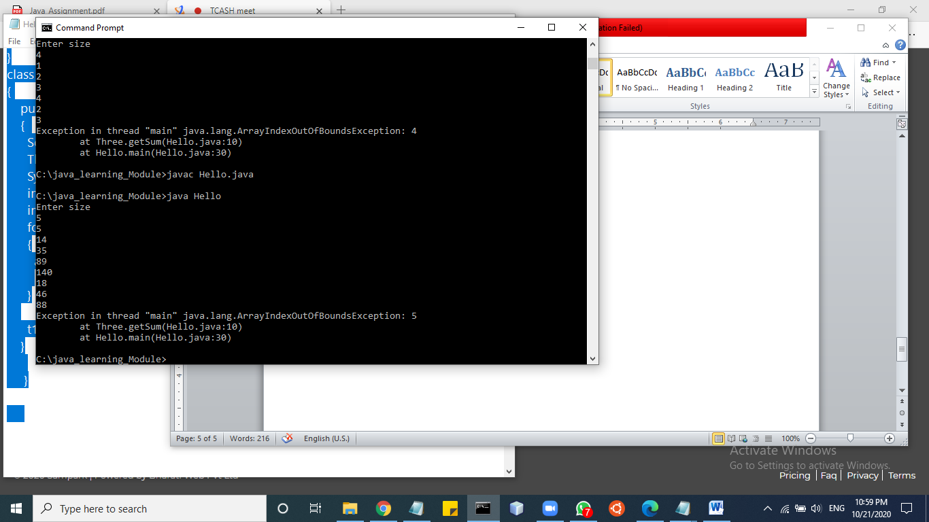

**Q3. Write a program which generates the series 1,4,27,16,125,36**

import java.util.Scanner;

class Program

{

void getSum(int n)

{

int c;

int c1;

for(int i=1;i<n;i++)

{

if(i%2==0){

c=i*i;

System.out.println(c);

}

else{

c1=i*i*i;

System.out.println(c1);

}

}

}

}

class Hello

{

public static void main(String args[])

{

Scanner sc=new Scanner(System.in);

int n=sc.nextInt();

Program p=new Program();

i(n);

}

}

**//Output**

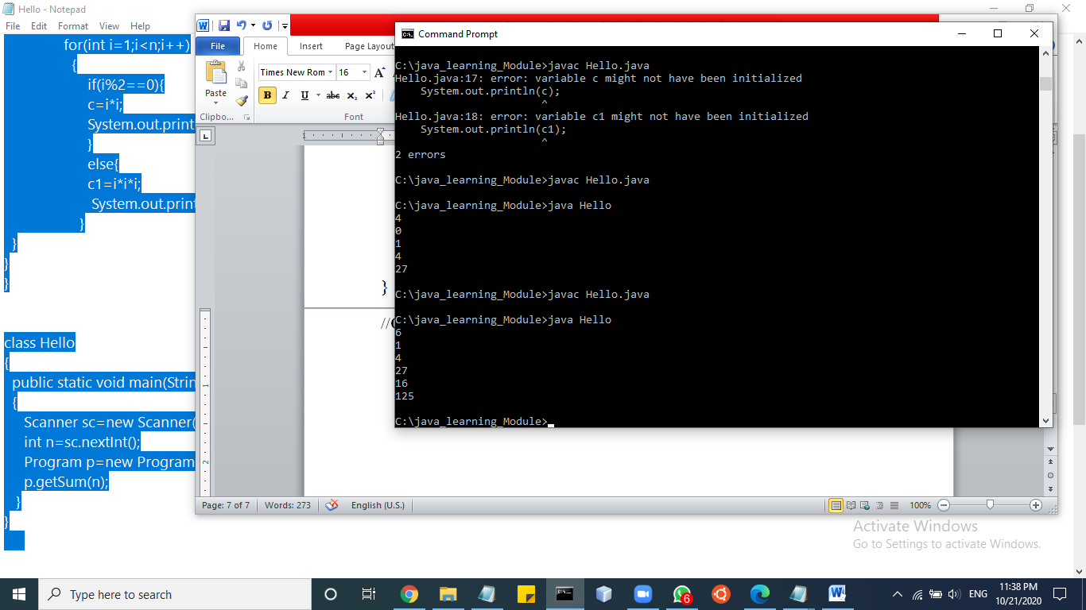

**Q4.Given an array of integers, print whether the numbers are in ascending order or in descending order or in random order without sorting**

Input: [5,14,35,90,139] Output: Ascending

Input: [88,67,35,14,-12] Output: Descending

Input: [65,14,129,34,7] Output: Random

import java.util.*;

class Hello1

{

public static void main(String args[])

{

Scanner sc=new Scanner(System.in);

System.out.print("Enter array elements");

int n=sc.nextInt();

int a[]=new int[n];

int count=0;

for(int i=0;i<n;i++)

{

a[i]=sc.nextInt();

}

for(int i=0;i<n;i++)

{

System.out.print(a[i]+" ");

}

for(int i=0;i<a.length;i++)

{

for(int j=i+1;i<a.length;i++)

if(a[j]>a[i])

{

count++;

}

}

int temp=1;

if(count==1)

{

System.out.print("Ascending");

}

for(int i=0;i<a.length;i++)

{

for(int j=0;j<a.length;j++)

{

if(a[j]<a[i])

{

temp--;

}

}

}

if(temp!=1)

{

System.out.println("descending");

}

}

}

**//Output**

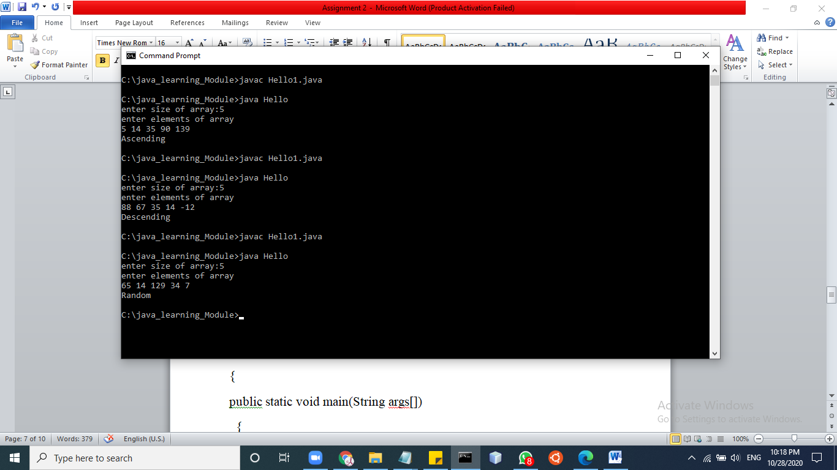

**Q5.Write a function which accepts a floating point number and counts the number of decimal places in the number without using a string.**

**Input: 45.286 Output: 3**

**Input: 3.14159 Output: 5**

import java.util.*;

class Anu

{

public static int num(double d){

int count=0;

while(d!=((int)d))

{

count++;

d=d*10;

}

return count;

}

public static void main(String args[])

{

int n;

n=num(45.286);

System.out.println(n);

}

}

//output

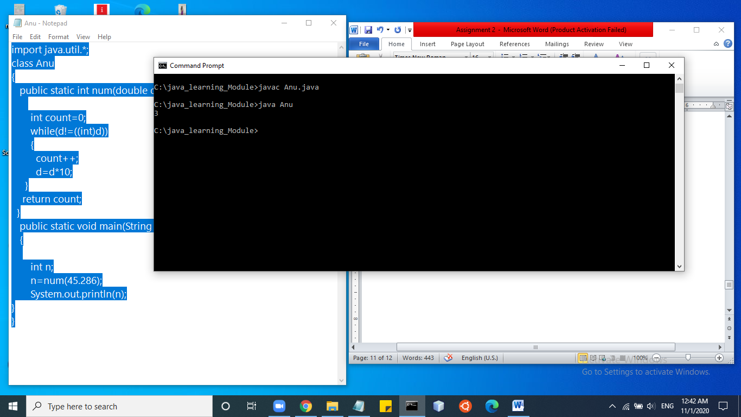

**Q6 Print the third-largest number in an array without sorting it Input: [ 24,54,31,16,82,45,67] Output: 54 (82 and 67 are the largest and second-largest)**

public class Anu{

public static int getThirdLargest(int[] a, int total){

int temp;

for (int i = 0; i < total; i++)

{

for (int j = i + 1; j < total; j++)

{

if (a[i] > a[j])

{

temp = a[i];

a[i] = a[j];

a[j] = temp;

}

}

}

System.out.println("Third Largest: "+a[total-3]+" ("+a[total-1]+" "+"and"+" "+a[total-2]+" are first and second largest no)");

return a[total-3];

}

public static void main(String args[]){

int a[]={1,2,5,6,3,2};

//int b[]={24,54,31,16,82,45,67};

//System.out.println("Third Largest: "+getThirdLargest(a,6));

int n=getThirdLargest(a,6);

}

}

**//Output**

